**Matrix Factorization: NMF**

Non-negative matrix factorization means there is matrix A which decomposes into two matrix B and CT whose elements are greater than equal to 0 i.e non-negative.

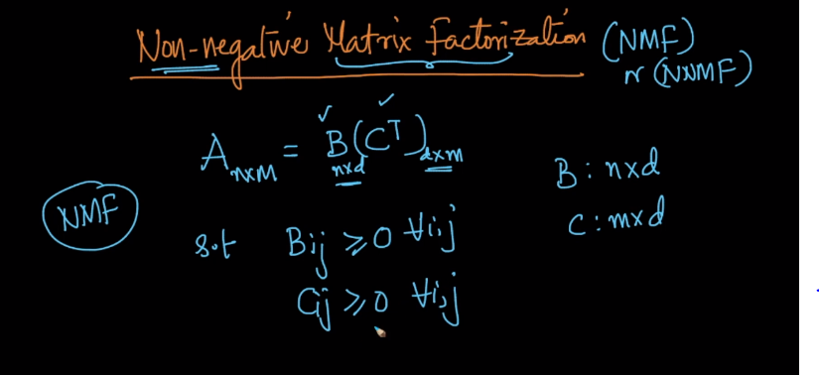

As shown below each cell of B and CT should contains non-negative values

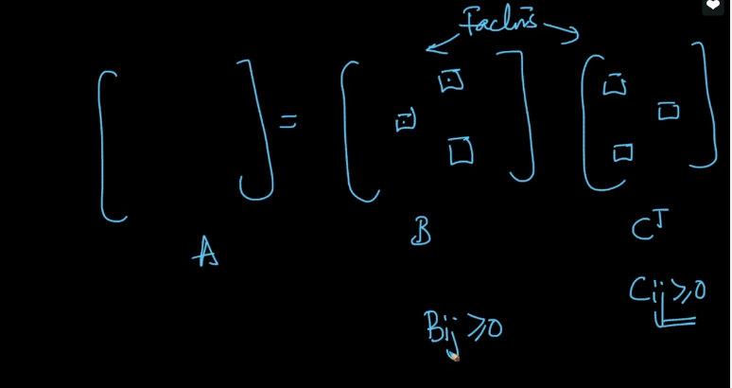

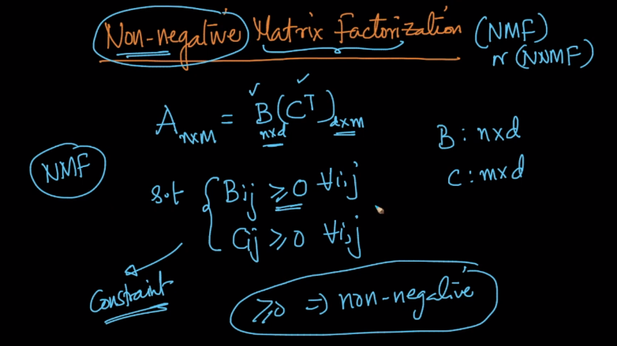

Comments :

